# Specification of WEBHOOK API FOR MANDATES FROM EATAPP **3 Days**

# Background

The ongoing notification of debit order.mandates from EAT mobile App. <https://www.electronicmandate.com/eat/> must be sent to Easipol using a webhook that listens for updates from the EatApp through a webhook and sends the information to Easipol using an API.Diagram

# Json that is will be exposed to the Webhook

* {
* "SigninID": "A34370FD-FD3A-42E5-8082-D3F0B28458CC",
* "MainMember": {
* "Reference": "EAT001",
* "Title": "Mr",
* "FirstName": "TestEAT",
* "MiddleName": "",
* "Surname": "TestEAT",
* "Premium": "149.00",
* "IdNumber": "8900000030084",
* "CellNumber": "0952654577",
* "StreetAddress": "465 Long Street, Randburg",
* "PostalCode": "2011",
* "City": "Johannesburg",
* "Province": "Gauteng",
* "Email": "email@gmail.com",
* "Country": "South Africa",
* "Signature": "",
* "IPAddress": "",
* "ActualDate": "2020-10-07T09:40:03.119Z",
* "UTM": "EAT App"
* },
* "BankDetails": {
* "Account_Holder": "Test Account Holder",
* "Bank": "FNB",
* "Branch_Code": "152621",
* "Account_Number": "12345678",
* "Type_of_Account": "SAVINGS",
* "StartDate": "2020-10-07T09:40:03.119Z",
* "Debit_Day": 1
* }
* }.

# We Establish Webhook

The EatAPP has a standard POSTing of the E-Mandates as JSON that will be posted to the Direct Rewards endpoint. The webhook URL will listen for postings and accept all POSTs.

The information in the JSON POST will then be translated to the Easipol API and posted to

You would then transform this JSON as it is received and pass it on to EasiPol via your API.

# We Establish Webhook

* 1. Click on the swagger link to access your API <https://apis.easipol.co.za/swagger/ui/index>
  2. The API will require a SignInID
     1. Should you see message below, manually add the “s” as highlighted below.
  3. Endpoint: <https://apis.easipol.co.za/api/JustRewards/AddMember>

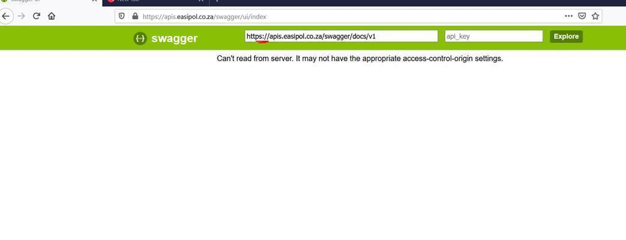

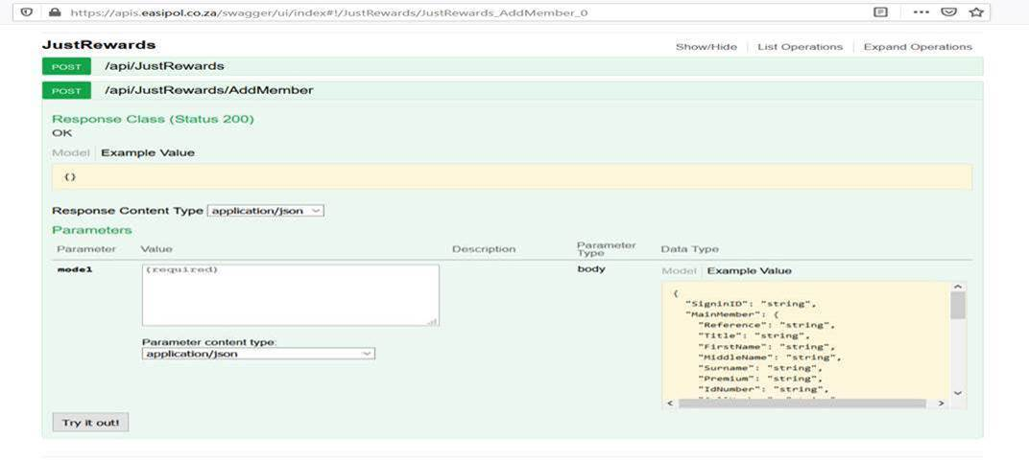

Direct Rewards will supply the API documentation and SigninId needed to establish connection to the Easipol API.